**EXPERIMENT NUMBER 2**

|  |  |  |
| --- | --- | --- |
| Name of Student: Sangeet Agrawal | PRN: 21070122140 | Section: CS-B |

# Title: Network forensic lab using Nmap tool

**Aim:** Study, understand and demonstrate network scanning tool

**Objective:** To make students understand and demonstrate various network scanning tools.

# Theory:

Nmap is a utility used for network discovery, network administration, and security auditing. It is also used to perform tasks such as network inventory, managing service upgrade schedules, and monitoring host or service uptime.

Here, we will use Nmap to discover a list of live hosts in the target network. We can use Nmap to scan the active hosts in the target network using various host discovery techniques such as ARP ping scan, UDP ping scan, ICMP ECHO ping scan, ICMP ECHO ping sweep, etc.

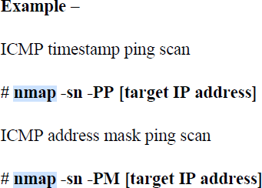

Nmap comes with various inbuilt scripts that can be employed during a scanning process in an attempt to find the open ports and services running on the ports. It sends specially crafted packets to the target host, and then analyzes the responses to accomplish its goal. Nmap includes many port scanning mechanisms (TCP and UDP), OS detection, version detection, ping sweeps, etc.

# Port Scanning Basics – from nmap.org

Nmap began as an efficient port scanner, and that remains its core function. The simple command **nmap *<target>*** scans 1,000 TCP ports on the host *<target>*. While many port scanners have traditionally lumped all ports into the open or closed states, Nmap is much more granular. It divides ports into six states: open, closed, filtered, unfiltered, open|filtered, or closed|filtered.

These states are not intrinsic properties of the port itself, but describe how Nmap sees them.

The six port states recognized by Nmap

* Open: An application is actively accepting TCP connections, UDP datagrams or SCTP associations on this port. Finding these is often the primary goal of port scanning. Open ports are also interesting for non-security scans because they show services available for use on the network.

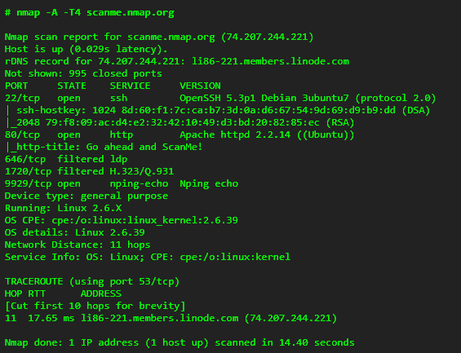

Soruce: <https://nmap.org/book/man.html>

* Closed: A closed port is accessible (it receives and responds to Nmap probe packets), but there is no application listening on it. They can be helpful in showing that a host is up on an IP address (host discovery, or ping scanning), and as part of OS detection.
* Filtered: Nmap cannot determine whether the port is open because packet filtering prevents its probes from reaching the port. The filtering could be from a dedicated firewall device, router rules, or host-based firewall software.
* Unfiltered: The unfiltered state means that a port is accessible, but Nmap is unable to determine whether it is open or closed. Only the ACK scan, which is used to map firewall rulesets, classifies ports into this state.
* open|filtered: Nmap places ports in this state when it is unable to determine whether a port is open or filtered. This occurs for scan types in which open ports give no response. The lack of response could also mean that a packet filter dropped the probe or any response it elicited
* closed|filtered: This state is used when Nmap is unable to determine whether a port is closed or filtered. It is only used for the IP ID idle scan.

# Tools to be practiced:

* 1. Nmap
  2. Angry IP Scanner
  3. Advanced IP Scanner
  4. Wireshark

# Reference web links:

1. <https://nmap.org/>
2. <https://www.stationx.net/nmap-cheat-sheet/>
3. <https://www.advanced-ip-scanner.com/>
4. <https://angryip.org/>

# Conclusion:

In this experiment, we used Nmap for network scanning and forensics, identifying open, closed, and filtered ports. We also practiced with Angry IP Scanner, Advanced IP Scanner, and Wireshark, highlighting the importance of these tools for network security and resource management.

# Implementation question:

1. Demonstrate various nmap options and submit screenshot - At least 12 different and important options, 3 Nmap Script Engine (NSE) scripts

12 Nmap Commands:

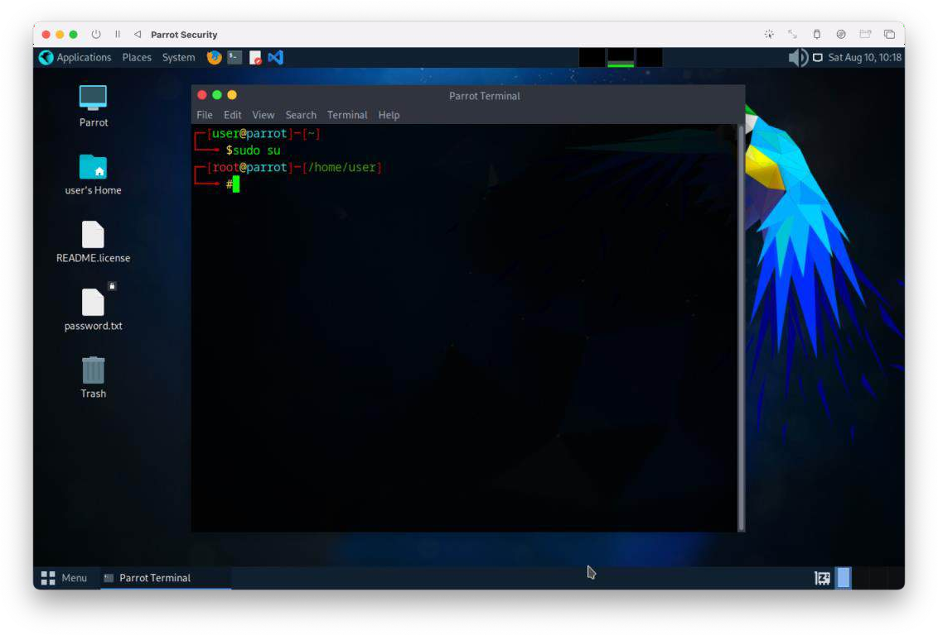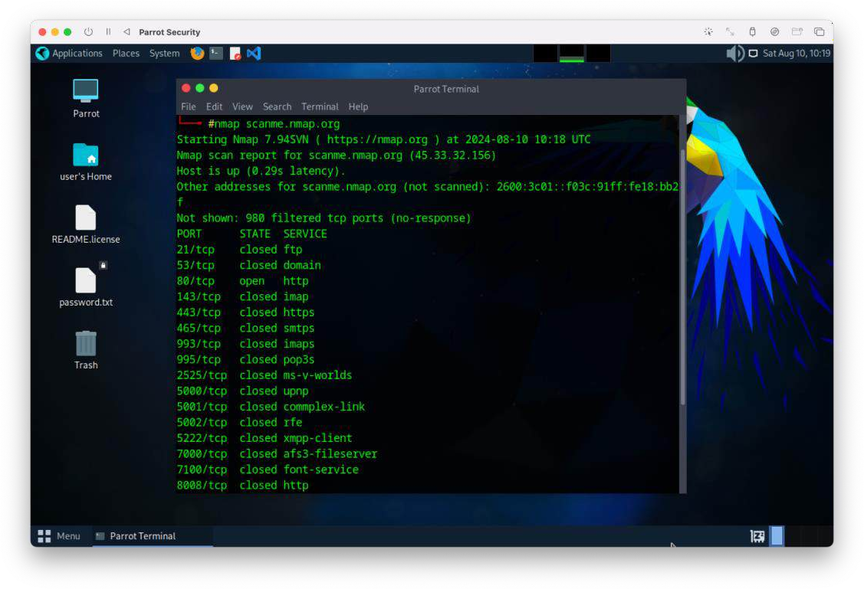

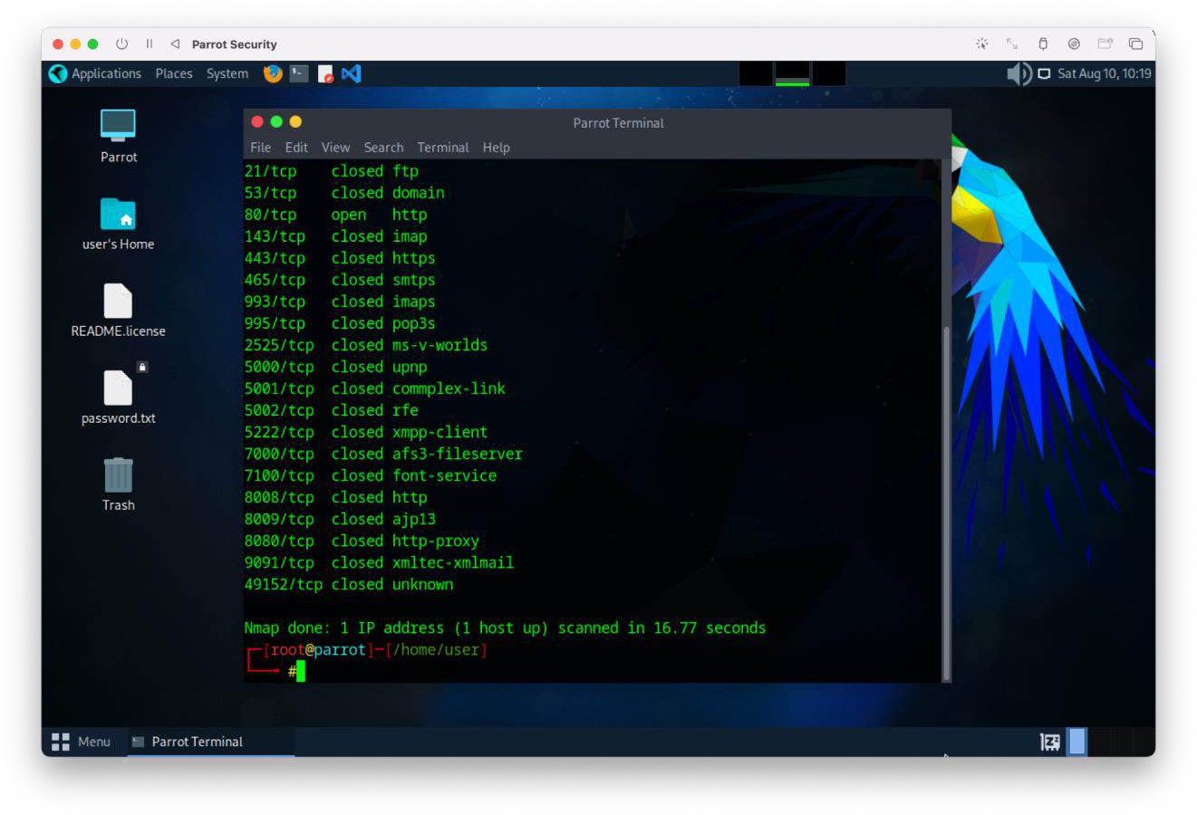

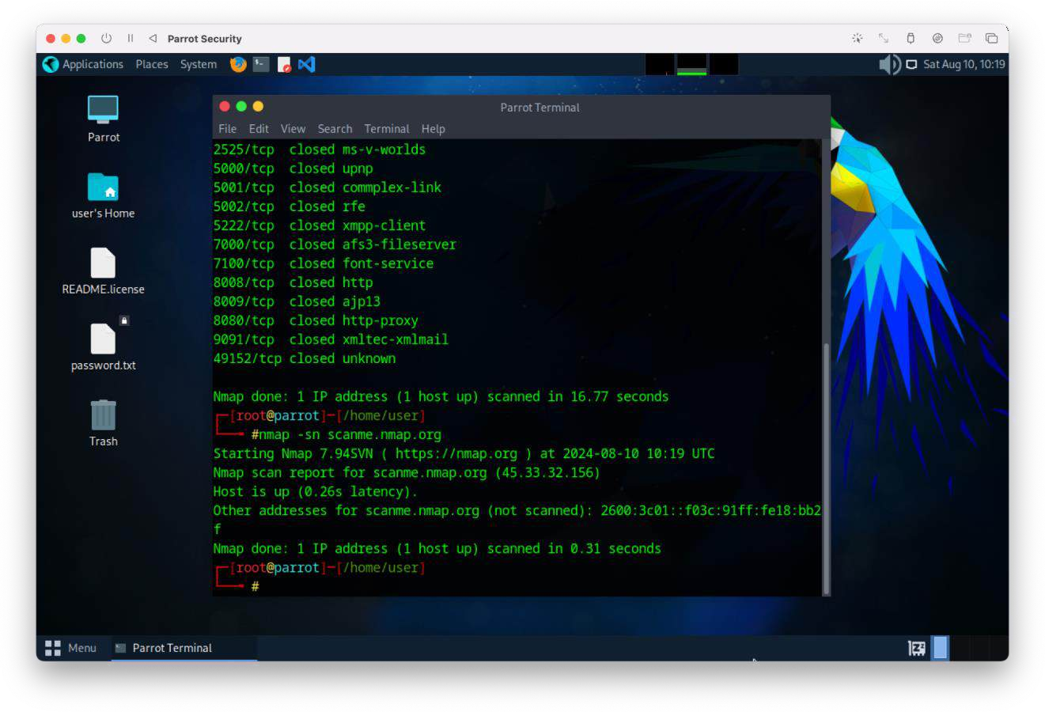

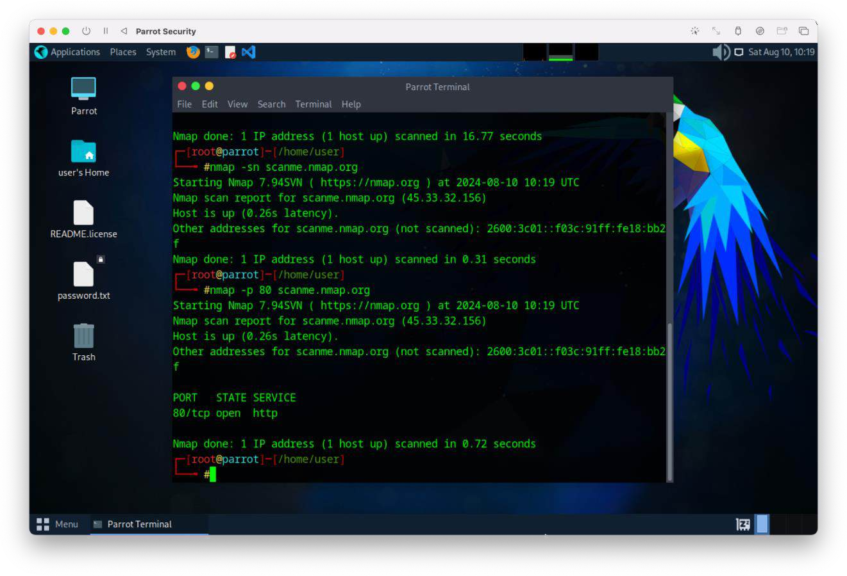

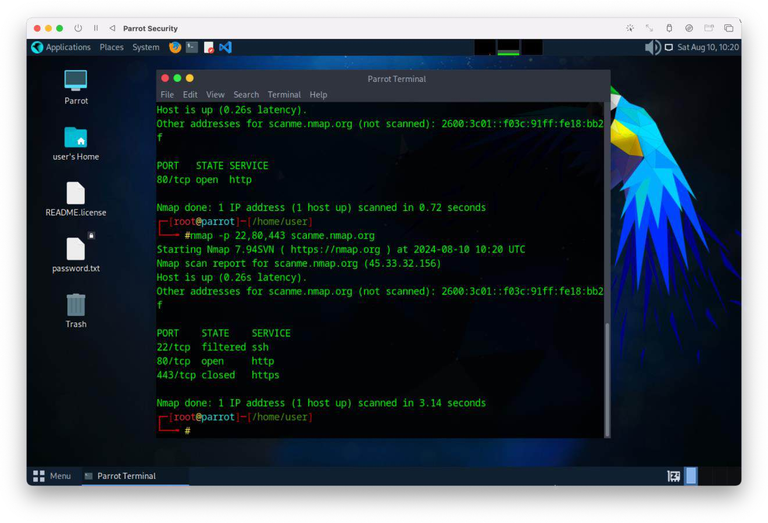

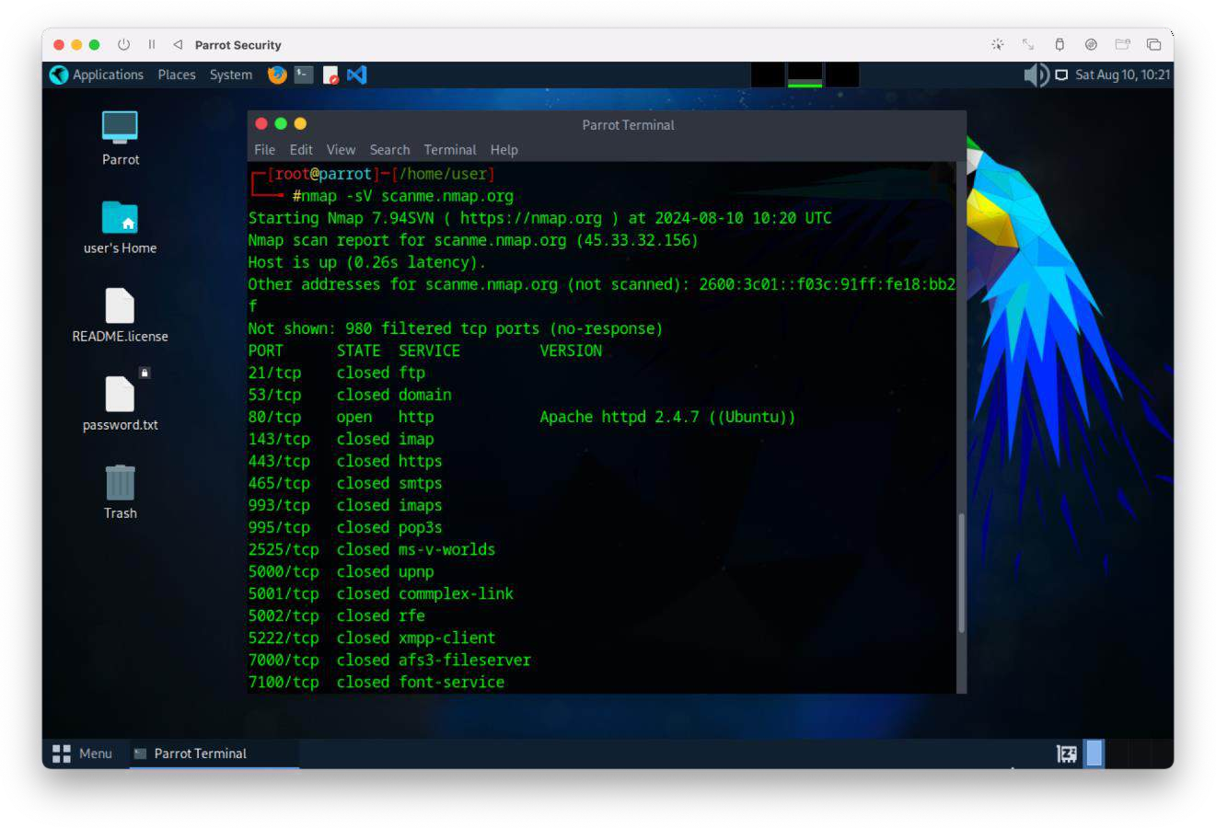

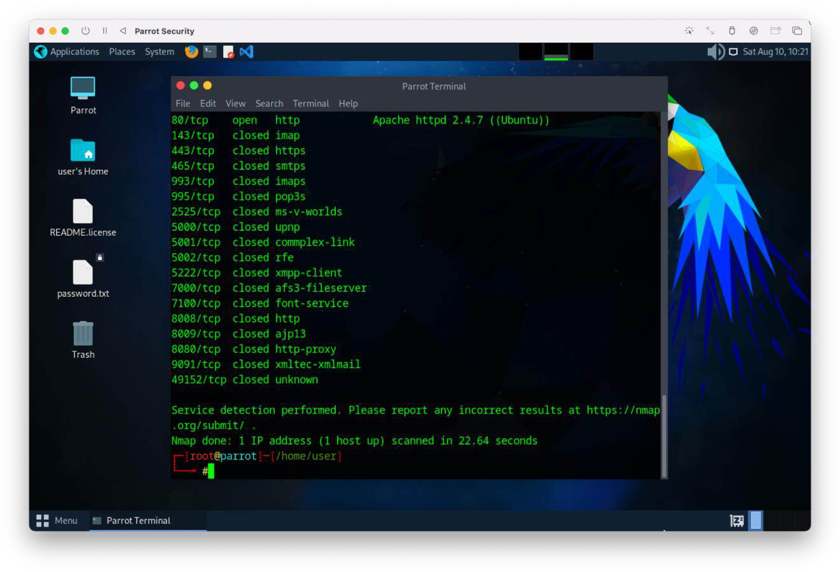

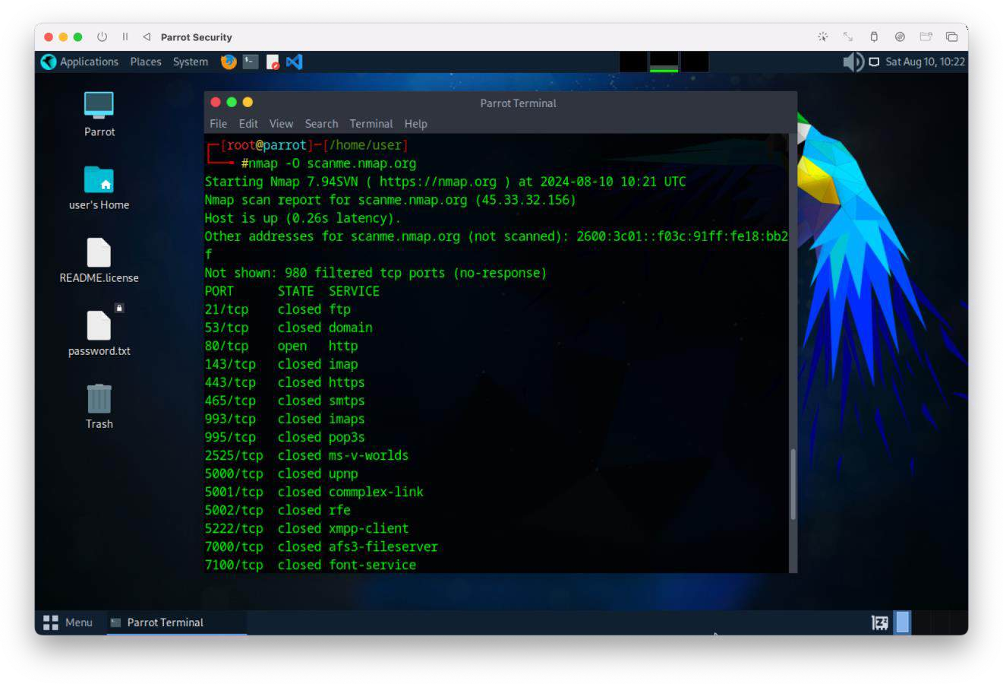

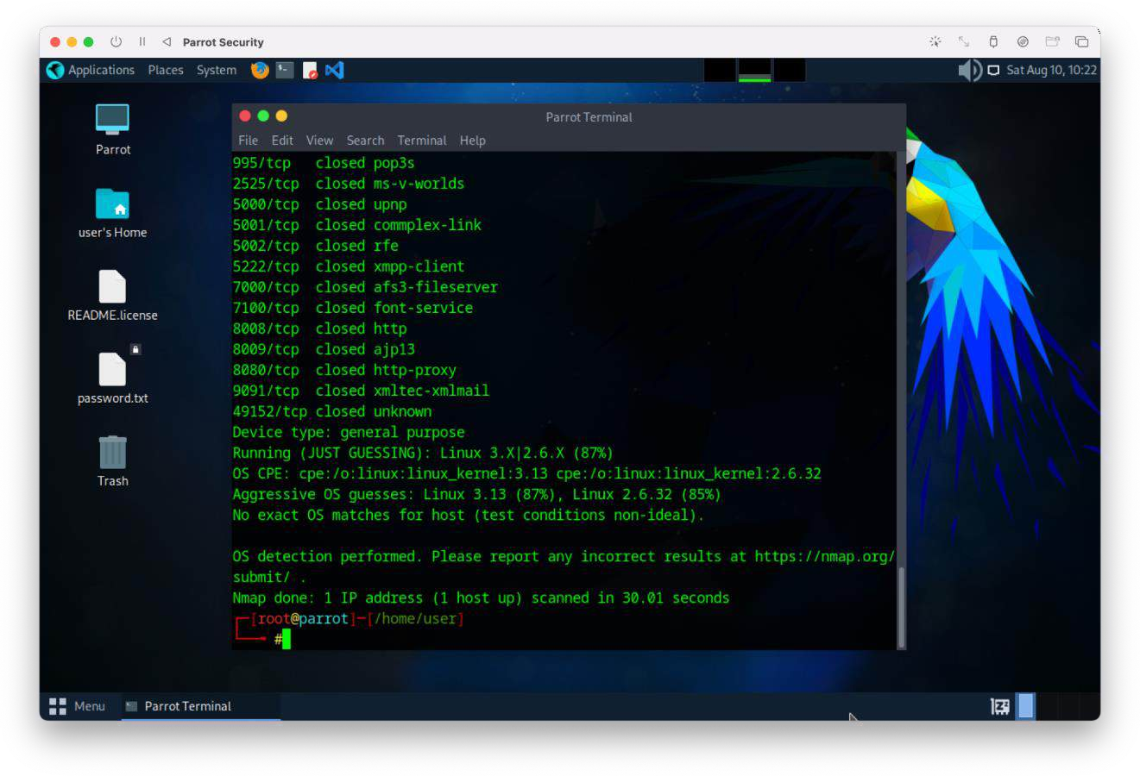

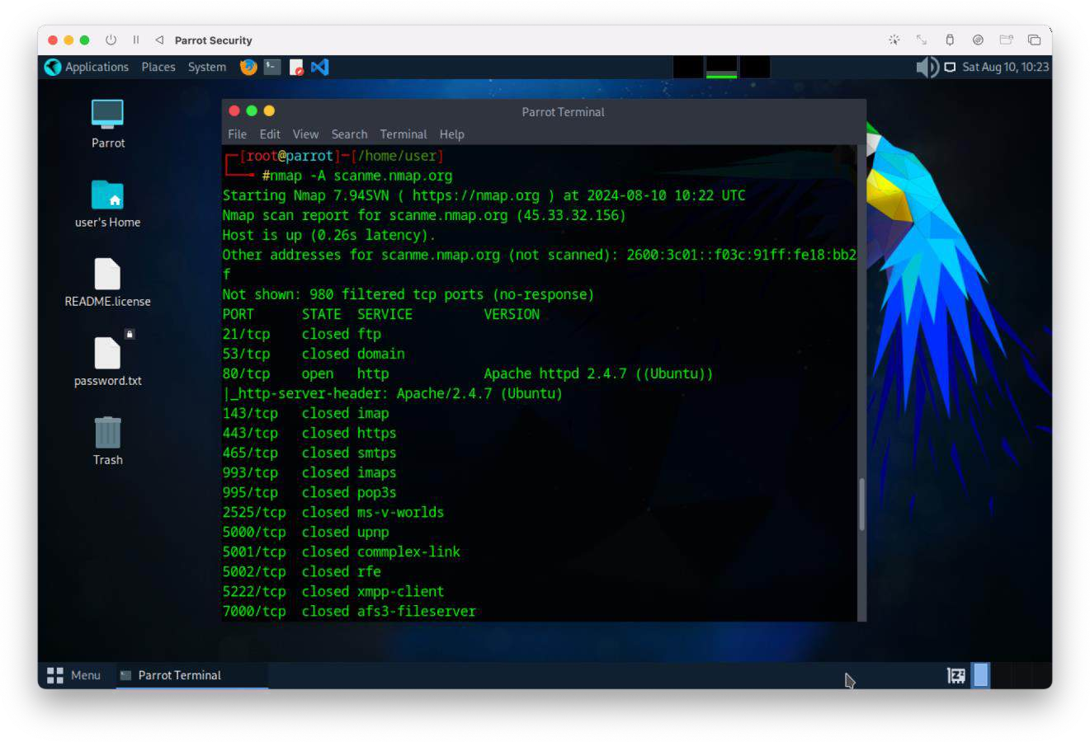

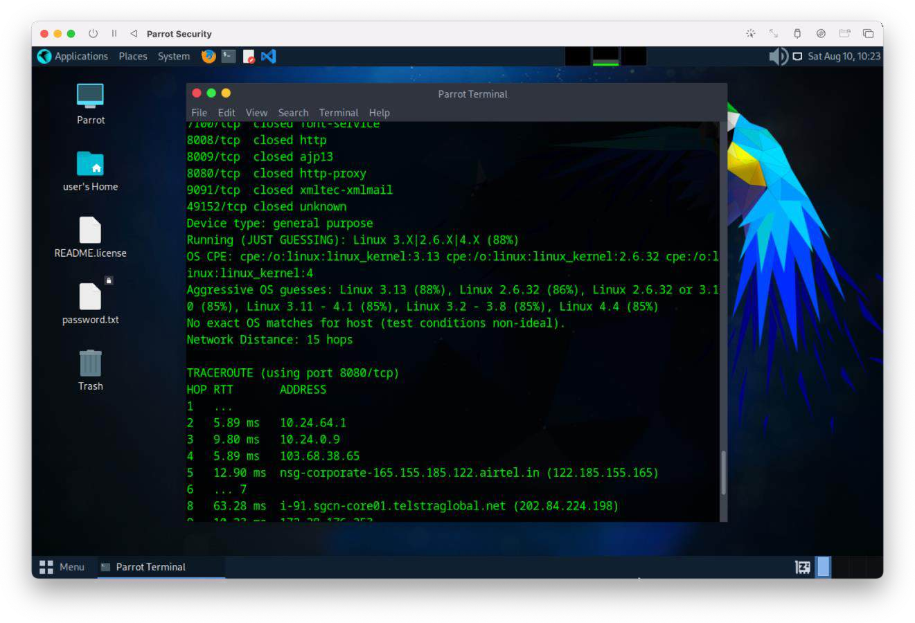

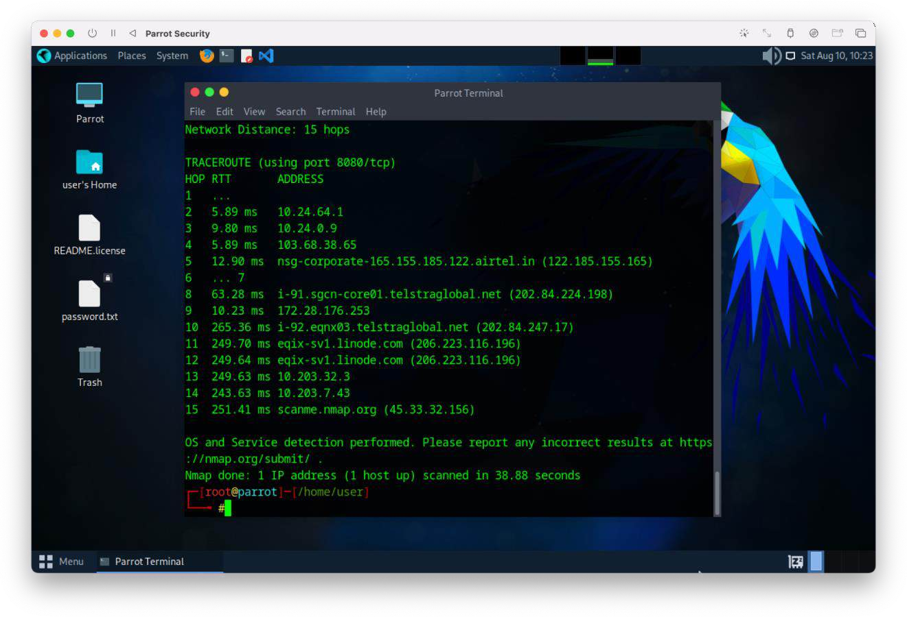

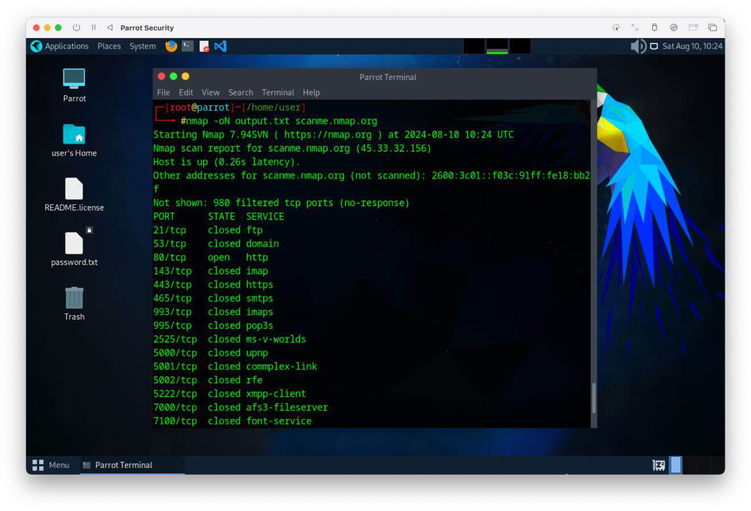

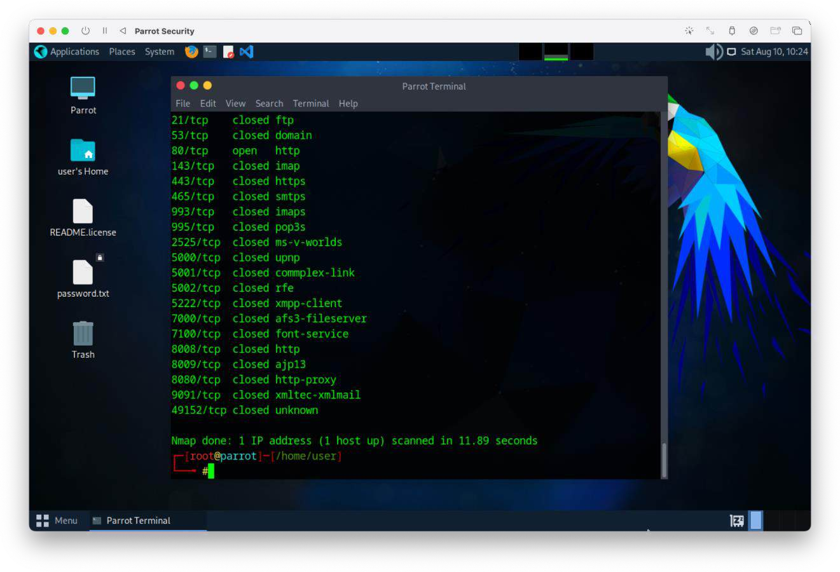

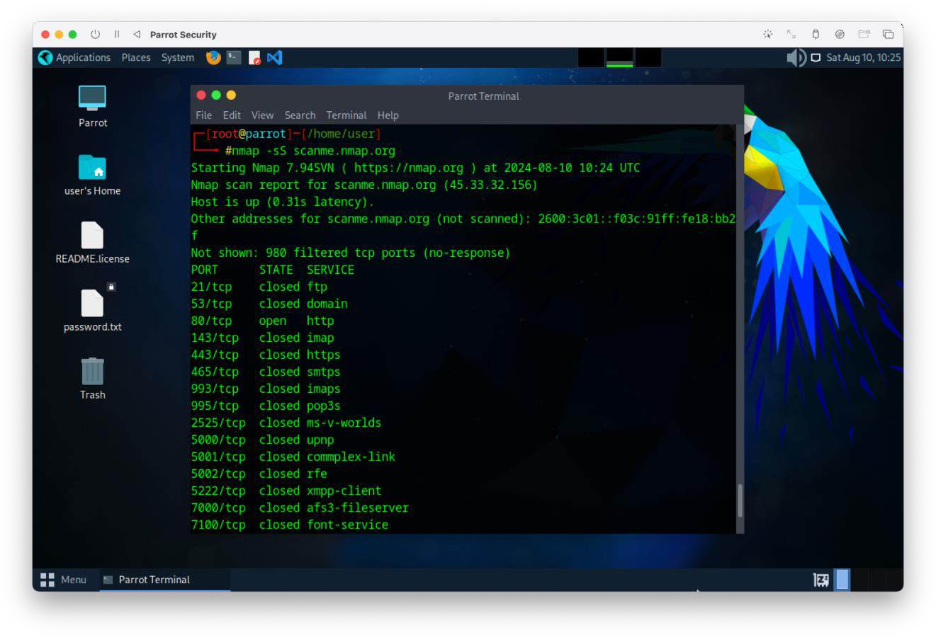

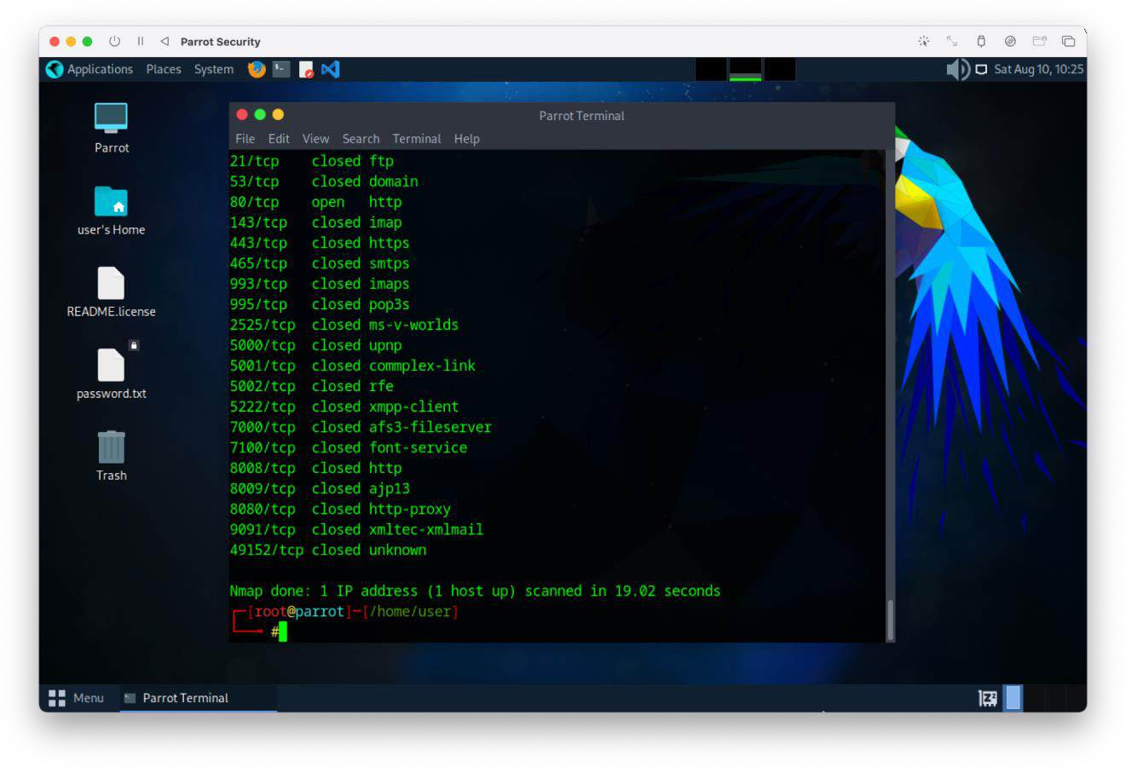

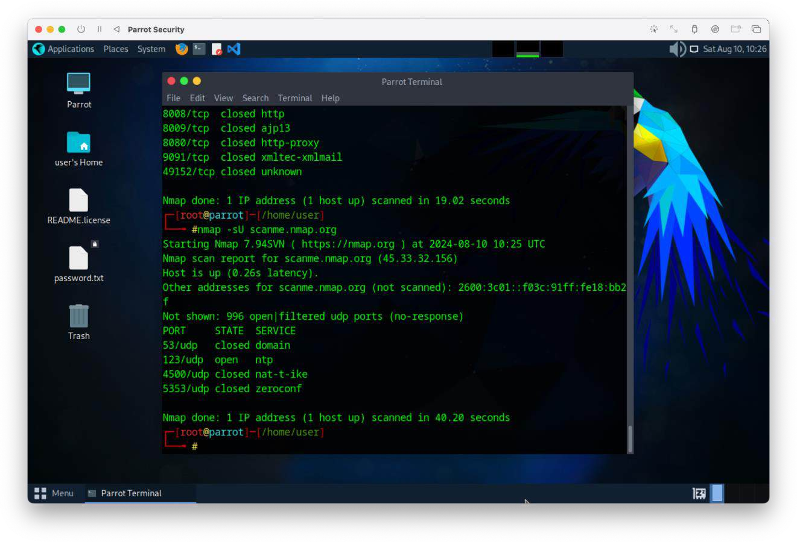

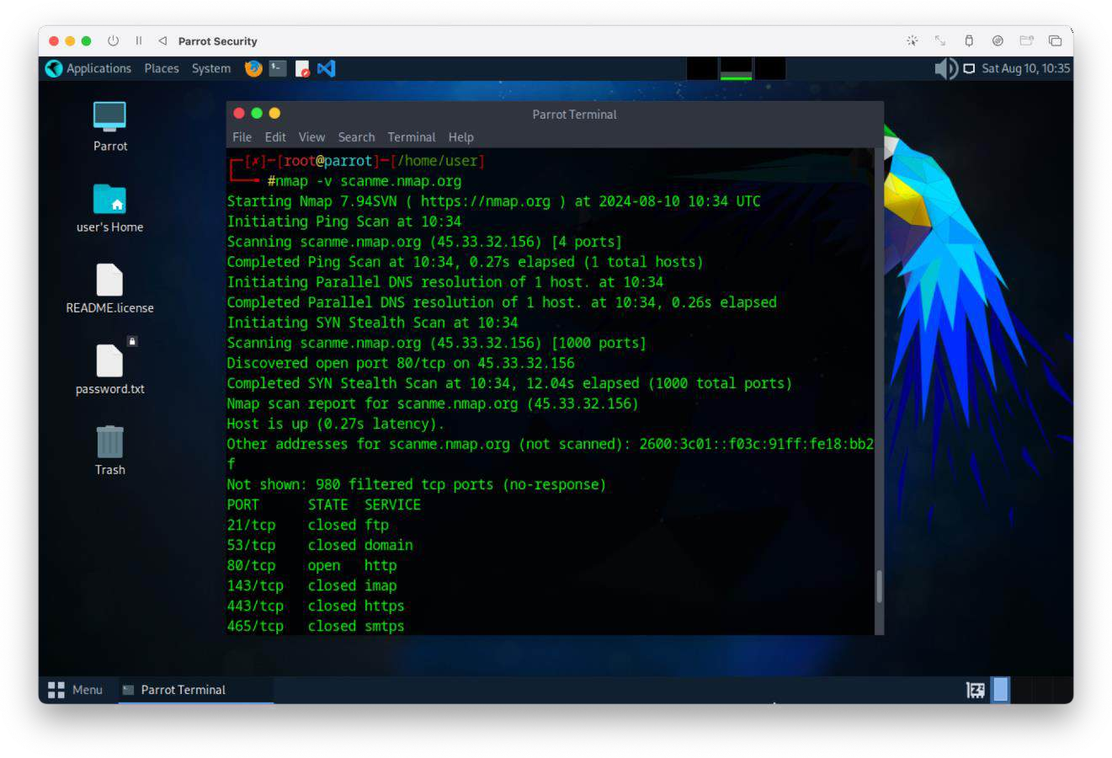

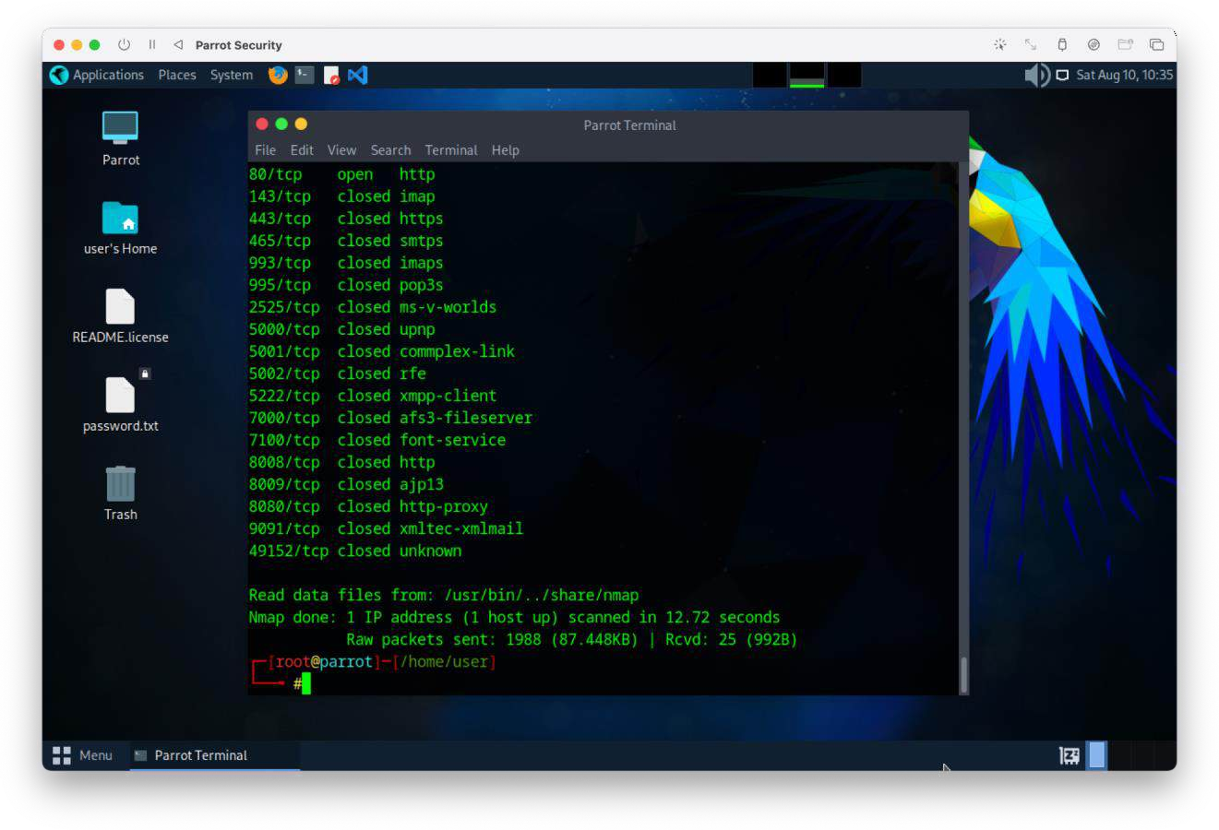

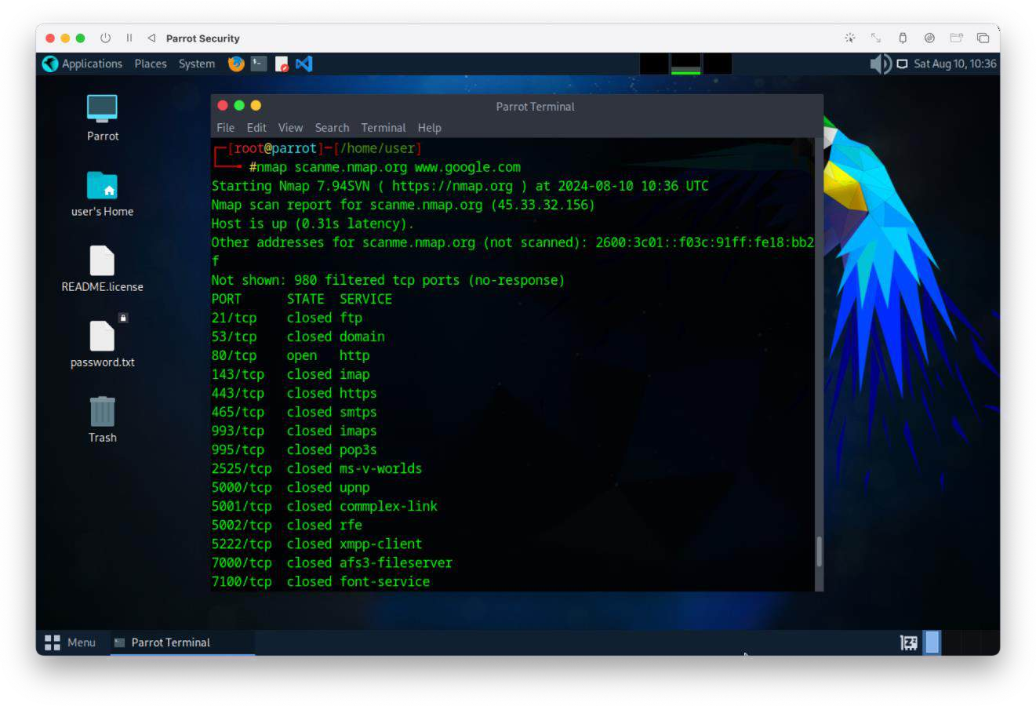

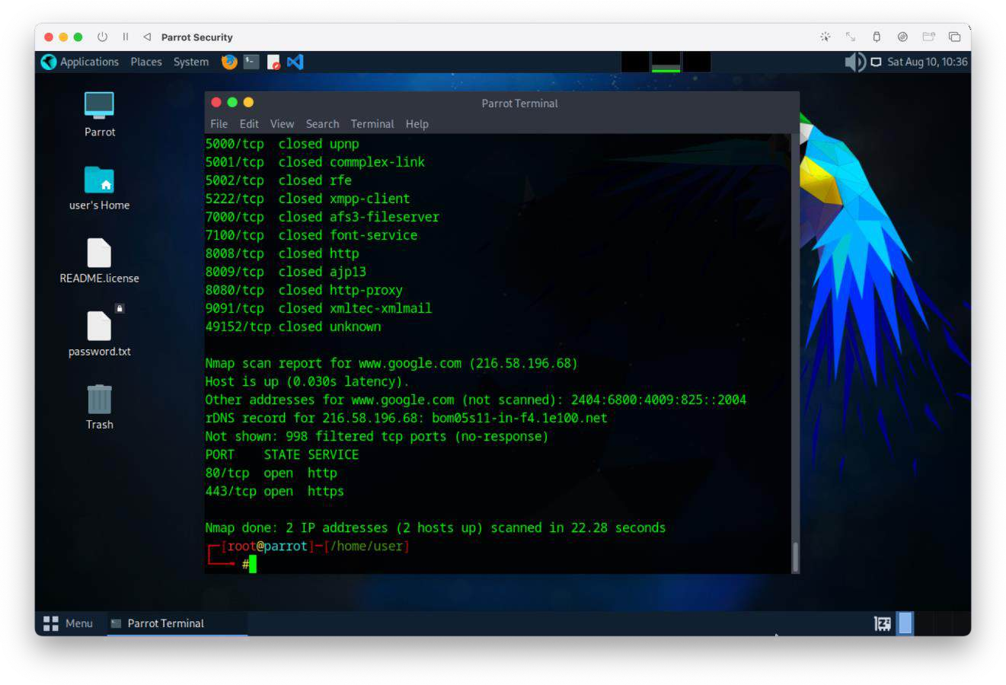

3 Nmap Script Engine (NSE) Script Commands:

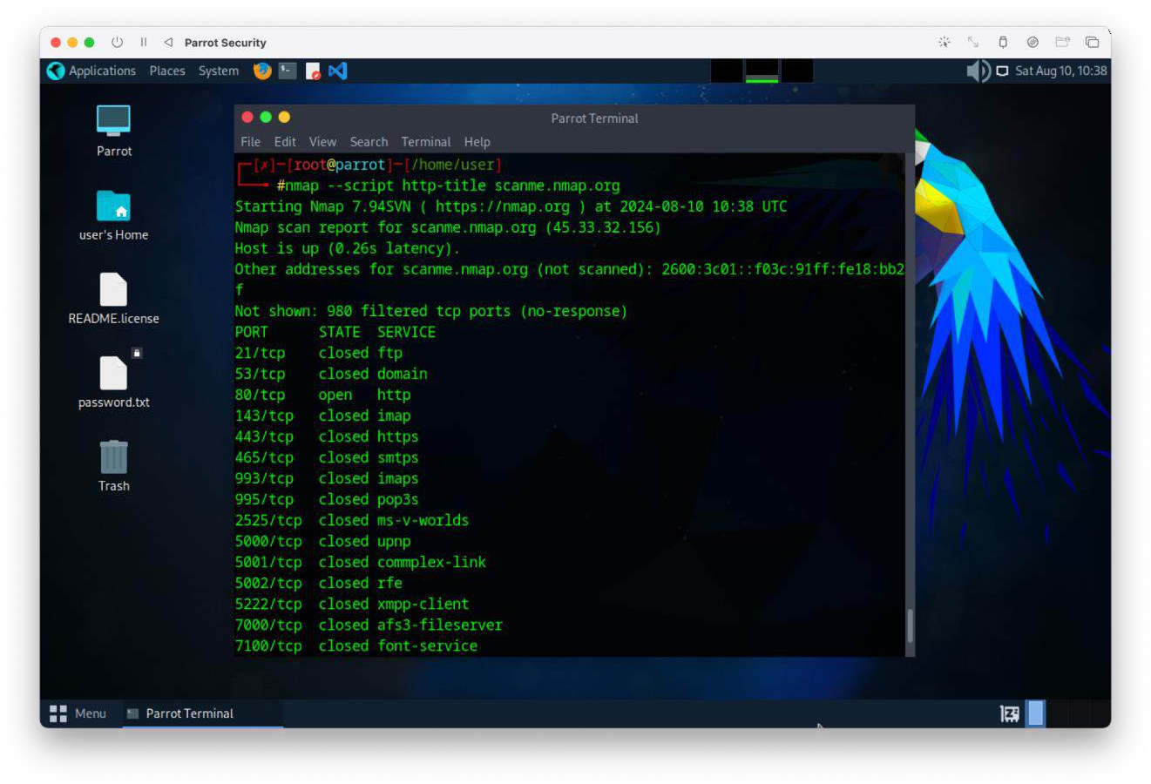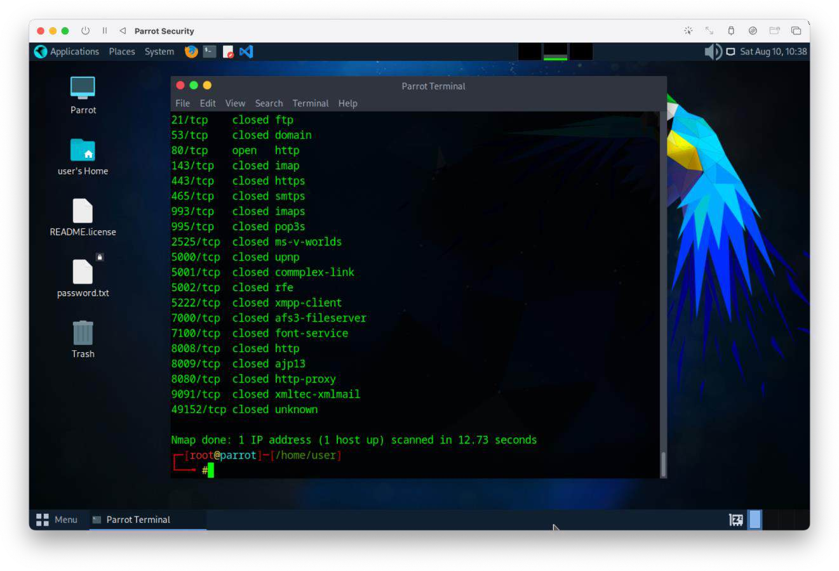

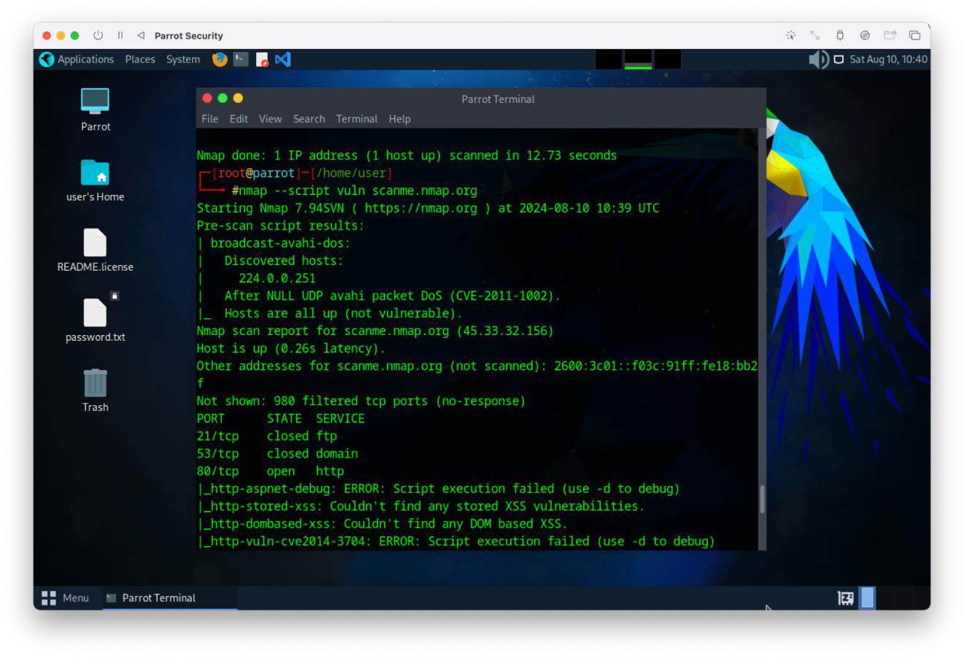

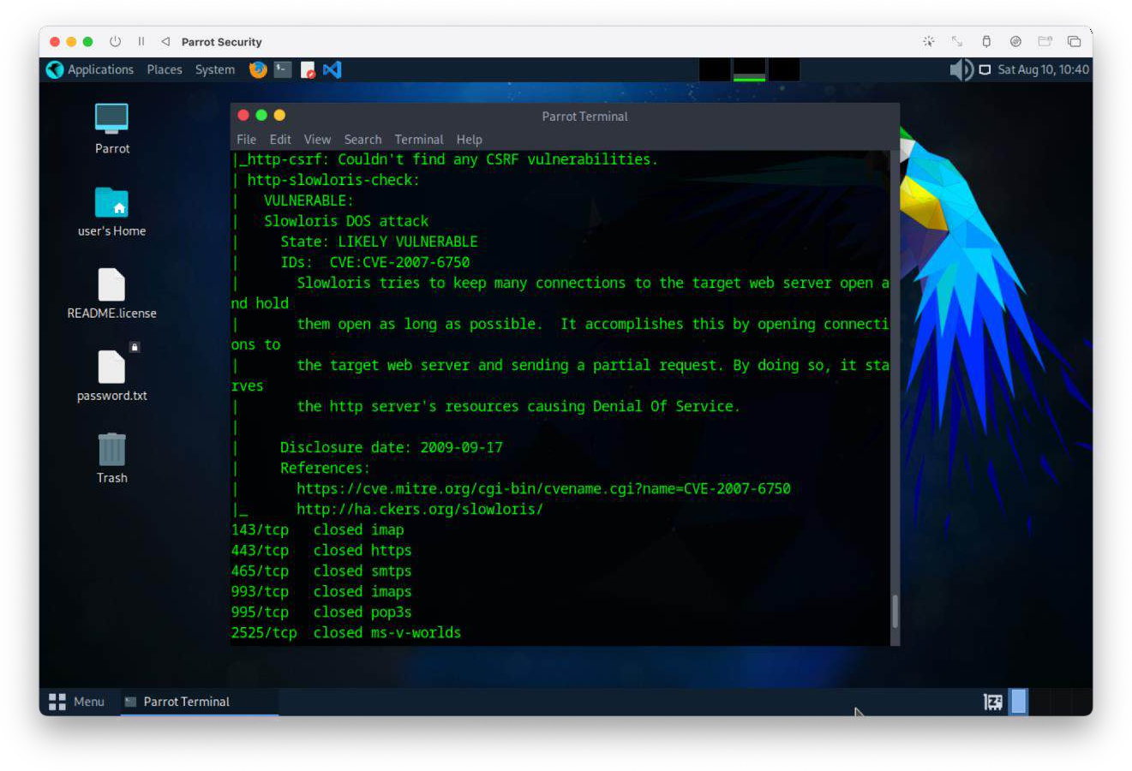

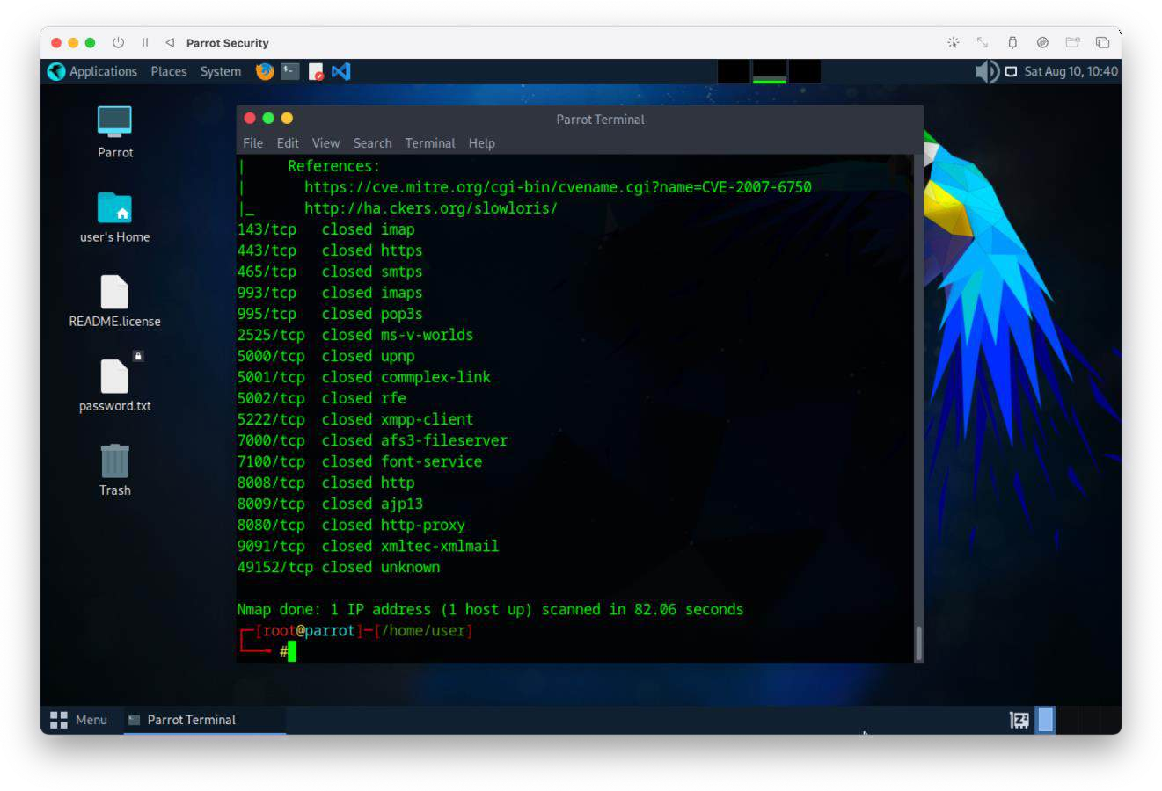

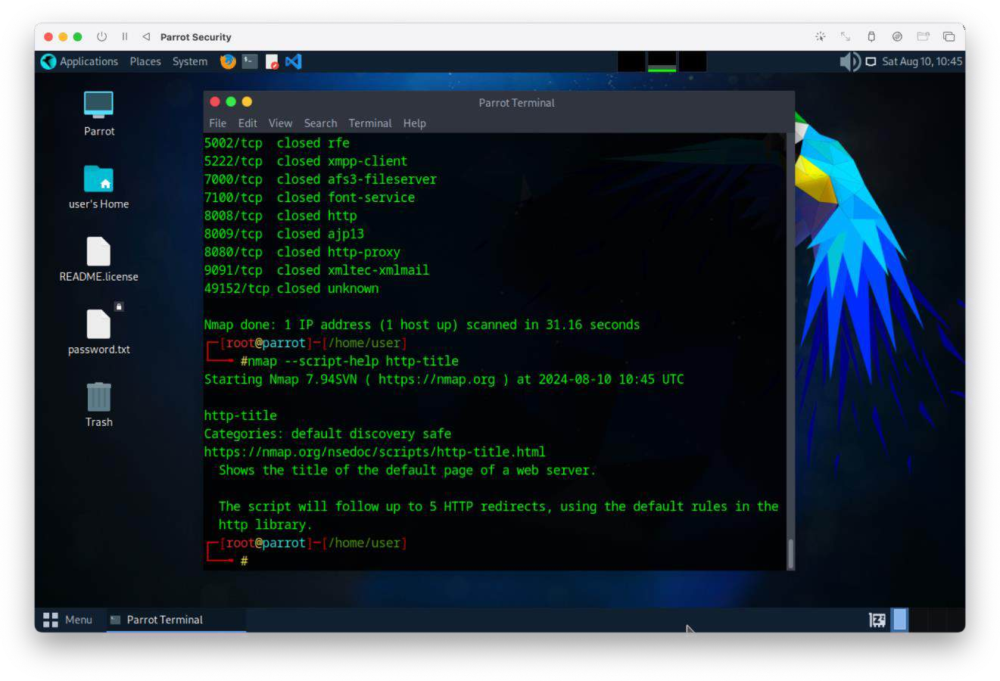

1. Demonstrate any network scanning free tools other than nmap

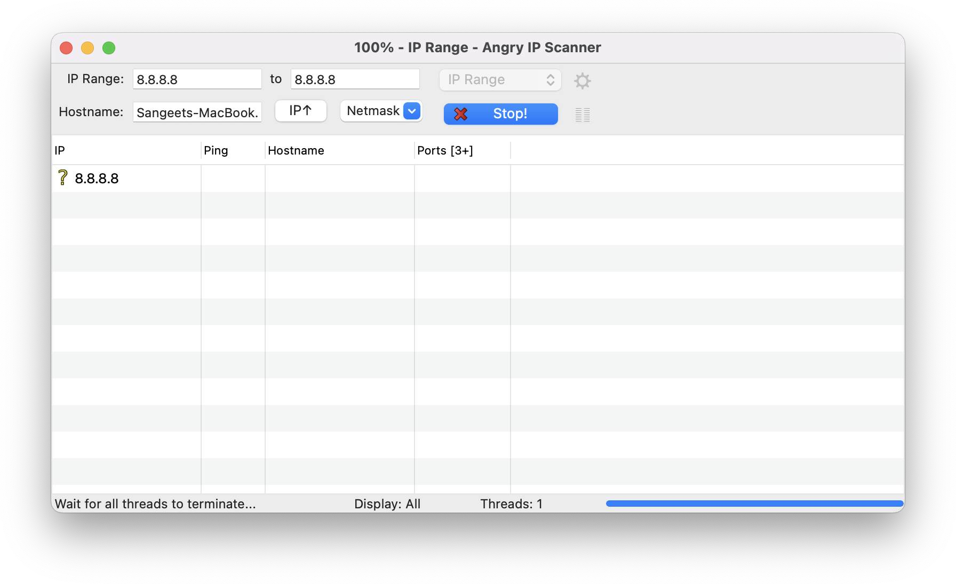

**Note:** Students are suggested to use Linux OS based tools or free Windows OS based tools.